

LAB MANUAL

R Programming Lab B.Sc. IT

2024 BATCH

Core Lab V: R Programming

Course Code | Course Name | Category | Hours/Week | Credits
24BIT52P | Lab: R Programming | Core Lab-V | 5 | 3

S.No  . | List of Programs
 | Sample Programs
1 | Write an R program to demonstrate expressions, variables, and basic functions.
2 | Create vectors, matrices, lists, and data frames in R and perform basic operations.
3 | Create matrices and perform addition, multiplication, transpose and determinant
4 | Create factor variables and analyze categorical data.
5 | Read a CSV file and display structure and summary.
6 | Read and write data from Excel, JSON, and text files.
7 | Perform data preprocessing on a dataset: handle missing values and omit null values.
8 | Create a data frame and explore using str(), summary(), head()
9 | Compute mean, median, mode, variance, and standard deviation.
10 | Validate regression assumptions (linearity, normality, homoscedasticity)
11 | Detect outliers using boxplots and statistical methods.
12 | Build a binary classification model using glm() with binomial family.
13 | Plot and interpret decision tree structure.
14 | a)Apply k-means clustering and visualize clusters.

- Compare clustering results using different values of k.
- Perform hierarchical clustering and plot dendrogram.
15 | - Generate association rules using arules package.  - Identify frequent itemsets using Apriori algorithm.  - Plot association rules using graphs.
 | Total Hours | 75
Text Books
1. | Seema Acharya (2024),”Data Analytics using R” (8th Edition), McGraw Hill  Education.
2. | Daniel Bell (2019),”R Programming: A Step-by-Step Guide for Absolute Beginners”  (1 st Edition), GUZZLER MEDIA.
Reference Books
1. | Peng, R. D (2014). R programming for Data Science. Lean Publishing.
2. | Prajapati, V. (2013). Big Data Analytics with R and Hadoop. Packt Publishing.
Web Resources (Swayam/NPTEL)
1. | Exploratory Data Analysis for Data Science with R Software — NPTEL (IIT Kanpur)
2. | Business Analytics and Data Mining Modeling Using R
3. | Descriptive Statistics with R Software

Experiment 1:

Demonstration of Expressions, Variables and Basic Functions in R

Aim

To write an R program that demonstrates the use of expressions, variables and basic built-in functions.

Algorithm
Step 1 : Start the process

Step 2 : Open R Studio and select File→ New File→ RScript

Step 3: Declare two variables and assign values. Step 4: Use arithmetic expressions and functions Step 5: Print the results.
Step 6: Stop the process.

Program
# Demonstration of Expressions, Variables and Basic Functions # Variables
a <- 20
b <- 10

# Arithmetic Expressions sum_result <- a + b difference <- a - b product <- a * b
quotient <- a / b power <- a^2

# Display Results print(paste("Addition =", sum_result))
print(paste("Subtraction =", difference))

print(paste("Multiplication =", product)) print(paste("Division =", quotient)) print(paste("Square of a =", power))

# Basic Functions
numbers <- c(5, 10, 15, 20, 25)

print(paste("Square Root of 25 =", sqrt(25))) print(paste("Mean =", mean(numbers))) print(paste("Maximum =", max(numbers))) print(paste("Minimum =", min(numbers))) print(paste("Length =", length(numbers))) print(paste("Sum =", sum(numbers)))

Output
Addition = 30
Subtraction = 10
Multiplication = 200
Division = 2 Square of a = 400
Square Root of 25 = 5
Mean = 15
Maximum = 25
Minimum = 5
Length = 5
Sum = 75

Result

Thus, the R program demonstrating expressions, variables, and basic functions was executed successfully and the results were verified.

Experiment 2

Creating Vectors, Matrices, Lists and Data Frames in R

Aim
To create vectors, matrices, lists and data frames in R and perform basic operations on them.

Algorithm

Step 1 : Start the process

Step 2 : Open R Studio and select File→New File→ RScript

Step 3: Declare vectors using c() and assign values.

Step 4: Declare Matrices with matrix function and assign values.

Step 5: Declare List with list function and assign values.

Step 6: Declare Data Frame with data.frame function and assign values.

Step 7: Print the results. Step 8: Stop the process. Program
# Vector Creation
v <- c(10, 20, 30, 40, 50)

print("Vector:") print(v)

print("Sum of Vector:") print(sum(v))

print("Mean of Vector:") 5print(mean(v))
# Matrix Creation
m <- matrix(c(1,2,3,4,5,6), nrow = 2, ncol = 3)

print("Matrix:") print(m)

print("Matrix Addition:") print(m + 5)

# List Creation
student <- list( Name = "John", Age = 21, Marks = 85)

print("List:") print(student)

# Data Frame Creation
df <- data.frame( RollNo = c(101,102,103), Name = c("Alice","Bob","Charlie"), Marks = c(90,85,88))

print("Data Frame:") print(df)

print("Average Marks:") print(mean(df$Marks))

print("Students with Marks > 85:") print(df[df$Marks > 85, ])

Output

Vector:
[1] 10 20 30 40 50

Sum of Vector:
[1] 150

Mean of Vector:
[1] 30

Matrix:
[,1] [,2] [,3]
[1,] 1 3 5
[2,] 2 4 6

Matrix Addition: [,1] [,2] [,3]

[1,] 6 8 10
[2,] 7 9 11

List:
$Name
[1] "John"

$Age
[1] 21

$Marks
[1] 85

Data Frame:
RollNo Name Marks
1 101 Alice 90
2 102 Bob 85
3 103 Charlie 88

Average Marks:
[1] 87.67

Students with Marks > 85: RollNo Name Marks
1 101 Alice 90
3 103 Charlie 88

Result
Thus, vectors, matrices, lists and data frames were successfully created in R and basic operations were performed and verified.

Experiment 3:

Create Matrices, Perform Addition, Multiplication, Transpose and Determinant in R Aim
To create matrices in R and perform basic matrix operations such as addition, multiplication, transpose and determinant calculation.

Algorithm

Step 1 : Start the process

Step 2 : Open R Studio and select File→ New File→ RScript

Step 3:Create two matrices A and B of the same order.

Step 4:Perform matrix addition using the + operator.

Step 5:Perform matrix multiplication using the %*% operator.

Step 6:Find the transpose of matrix A using the t() function.

Step 7:Calculate the determinant of matrix A using the det() function.

Step 8:Display all the results and stop.

Program

# Create Matrix A
A <- matrix(c(1, 2, 3, 4), nrow = 2, ncol = 2)

# Create Matrix B
B <- matrix(c(5, 6, 7, 8), nrow = 2, ncol = 2)

# Display matrices cat("Matrix A:\n") print(A)

cat("Matrix B:\n") print(B)

# Matrix Addition add_result <- A + B
cat("\nAddition of A and B:\n") print(add_result)

# Matrix Multiplication mult_result <- A %*% B
cat("\nMultiplication of A and B:\n") print(mult_result)

# Transpose of Matrix A transpose_result <- t(A) cat("\nTranspose of Matrix A:\n") print(transpose_result)

# Determinant of Matrix A det_result <- det(A) cat("\nDeterminant of Matrix A:\n") print(det_result)

Output

Matrix A
[,1] [,2]
[1,] 1 3
[2,] 2 4

Matrix B

[,1] [,2]
[1,] 5 7
[2,] 6 8

Addition of A and B
[,1] [,2]
[1,] 6 10
[2,] 8 12

Multiplication of A and B

[,1] [,2]
[1,] 23 31
[2,] 34 46

Transpose of Matrix A

[,1] [,2]
[1,] 1 2
[2,] 3 4

Determinant of Matrix A

[1] -2

Result
Thus, matrices were successfully created in R and the operations of matrix addition, matrix multiplication, transpose and determinant were performed and verified.

Experiment:4

Create Factor Variables and Analyze Categorical Data Using R

Aim

To create factor variables in R and analyze categorical data using frequency tables and summary statistics.

Algorithm

Step 1: Create a categorical variable containing student grades.

Step 2: Convert the categorical variable into a factor using the factor() function.

Step 3: Display the factor variable.

Step 4: Display the levels of the factor.

Step 5: Generate a frequency table using the table() function.

Step 6: Generate a summary of the factor variable using the summary() function.

Step 7: Display all outputs.

Program

# Create categorical data
grades <- c("A", "B", "A", "C", "B", "A", "C", "B", "A", "B")

# Convert to factor grade_factor <- factor(grades)

# Display factor variable cat("Factor Variable:\n") print(grade_factor)

# Display levels cat("\nLevels of Factor:\n") print(levels(grade_factor))

# Frequency table cat("\nFrequency Table:\n") print(table(grade_factor))

# Summary of factor data cat("\nSummary:\n") print(summary(grade_factor))

Output

Factor Variable
[1] A B A C B A C B A B
Levels: A B C

Levels of Factor
[1] "A" "B" "C"

Frequency Table

grade_factor A B C
4 4 2

Summary
A B C 4 4 2

Result

Thus, factor variables were successfully created in R using the factor() function, and categorical data was analyzed using levels(), table() and summary() functions.

--------------------------------------------------------------------------------------------------------------------

Experiment 5:

Read a CSV File and Display Structure and Summary

Aim

To read a CSV file and display its structure and summary statistics.

Algorithm
Step 1: Create a student detail file and save it as student.csv (For Ex: student.csv file stored in E:/RPrograms/ folder) with 10 rows and 3 columns namely RollNo, Name,Marks.

Step 2 : Import CSV file using read.csv().

Step 3 : Store data in a data frame.

Step 4: Display structure using str().

Step 5 : Display summary using summary().

Program
data <- read.csv("H:/RPrograms/student.csv") str(data)
summary(data)

Output
'data.frame': 10 obs. of 3 variables:
$ RollNo : int

$ Name : chr
$ Marks : int

Summary: RollNo Marks
Min:1.0 Min:45 Max:10.0 Max:95
Mean:5.5 Mean:72

Result

CSV file was successfully imported and analyzed.

Experiment 6:

Read and Write Data from Excel, JSON and Text Files

Aim

To perform file operations using Excel, JSON and text files.

Algorithm

Step 1: Install required packages. Step 2 :Read Excel using read_excel(). Step 3: Read JSON using fromJSON().
Step 4: Read text file using readLines().

Step 5: Write data to files.

Program

install.packages("readxl") install.packages("writexl") install.packages("jsonlite")

library(readxl) library(writexl) library(jsonlite)
# Create Data Frame student <- data.frame( ID = c(101,102,103),
Name = c("Anu","Bala","Chitra"), Marks = c(85,90,88)
)
# Excel

write_xlsx(student, "H:/2026_RPrograms/student.xlsx") excel_data <- read_excel("H:/2026_RPrograms/student.xlsx") # JSON
write_json(student, "H:/2026_RPrograms/student.json", pretty = TRUE) json_data <- fromJSON("H:/2026_RPrograms/student.json")

# Text write.table(student,
"H:/2026_RPrograms/student.txt", sep = "\t",
row.names = FALSE) text_data <- read.table(

"H:/2026_RPrograms/student.txt", header = TRUE,
sep = "\t"

)

cat("Excel Data\n") print(excel_data) cat("\nJSON Data\n") print(json_data) cat("\nText Data\n") print(text_data) Output
Excel Data

# A tibble: 3 × 3
ID Name Marks
<dbl> <chr> <dbl>
1 101 Anu 85
2 102 Bala 90
3 103 Chitra 88

JSON Data

ID Name Marks
1 101 Anu 85
2 102 Bala 90
3 103 Chitra 88

Text Data

ID Name Marks
1 101 Anu 85
2 102 Bala 90
- 103 Chitra 88

Result

Data was successfully read and written in multiple formats.

Experiment: 7

Data Preprocessing on a Dataset – Handling Missing Values and Omitting Null Values in R Aim
To perform data preprocessing on a dataset by identifying, handling and removing missing values (NA) and null values in R.
Step 1: Create or load a dataset.

Step 2: Identify missing values using is.na().

Step 3: Count the number of missing values.

Step 4: Replace missing values with appropriate statistics such as mean.

Step 5: Verify that missing values are replaced.

Step 6: Use na.omit() to remove rows containing missing values.

Step 7: Display the cleaned dataset.

Step 8: Check for NULL values using is.null(). Step 9: Remove or replace NULL values if present. Step 10: Display the final preprocessed dataset.

Program

# Data Preprocessing in R
# Creating a sample dataset with missing values student_data <- data.frame(
RollNo = c(101,102,103,104,105), Marks = c(85, NA, 78, 90, NA),
Attendance = c(92,88,NA,95,80)
)
cat("Original Dataset\n") print(student_data)
# Checking missing values

cat("\nMissing Values in Dataset\n") print(is.na(student_data))

# Counting missing values

cat("\nTotal Missing Values\n") print(sum(is.na(student_data)))

# Replacing missing values with mean

student_data$Marks[is.na(student_data$Marks)] <-mean(student_data$Marks, na.rm = TRUE)

student_data$Attendance[is.na(student_data$Attendance)] <-mean(student_data$Attendance, na.rm = TRUE)

cat("\nDataset after Replacing Missing Values\n") print(student_data)
# Creating another dataset with missing values

employee_data <- data.frame( ID = c(1,2,3,4),
Salary = c(25000, NA, 30000, 28000),
Experience = c(2,4,NA,5)
)

cat("\nEmployee Dataset\n") print(employee_data)

# Removing rows with missing values clean_data <- na.omit(employee_data)
cat("\nDataset after Removing Missing Values\n") print(clean_data)

# Demonstration of NULL value x <- NULL
cat("\nChecking NULL Value\n") print(is.null(x))

Output

Original Dataset
RollNo Marks Attendance
1 101 85 | 92
2 102 NA | 88
3 103 78 | NA
4 104 90 | 95
5 105 NA | 80

Missing Values in Dataset RollNo Marks Attendance
[1,] FALSE FALSE FALSE [2,] FALSE TRUE FALSE [3,] FALSE FALSE TRUE [4,] FALSE FALSE FALSE [5,] FALSE TRUE FALSE

Total Missing Values
[1] 3
Dataset after Replacing Missing Values RollNo Marks Attendance
1 101 85.00000 92.00

2 102 84.33333 | 88.00
3 103 78.00000 | 88.75
4 104 90.00000 | 95.00
5 105 84.33333 | 80.00

Employee Dataset
ID Salary Experience
1 1 | 25000 | 2
2 2 | NA | 4
3 3 | 30000 | NA
4 4 | 28000 | 5

Dataset after Removing Missing Values ID Salary Experience
1 1 25000 2
- 4 28000 5

Checking NULL Value
- TRUE

Result:
Thus, the dataset was successfully preprocessed in R by identifying missing values, replacing them with mean values, omitting rows containing missing values, checking for NULL values, and obtaining a clean dataset suitable for further analysis.

Experiment:8

Creating a Data Frame and Exploring Data Using str(), summary() and head() in R Aim
To create a data frame in R and explore its structure and contents using the functions str(), summary() and head().

Algorithm

Step 1 : Start the program.

Step 2 : Create a data frame containing student details such as Roll Number, Name, Age, Marks, and Department.

Step 3 : Display the complete data frame.

Step 4 : Use str() to examine the structure of the data frame.

Step 5 : Use summary() to obtain statistical summaries of each column.

Step 6 : Use head() to display the first six records.

Step 7 : Interpret the results.

Step 8 : Stop the program.

Program

# Creating a Data Frame student_data <- data.frame(
RollNo = c(101,102,103,104,105,106,107,108),

Name = c("Anu","Bala","Chitra","Deepak",

"Elan","Farah","Gokul","Hari"),

Age = c(18,19,18,20,19,18,21,20),

Marks = c(85,78,92,88,75,95,81,89),

Department = c("CSE","ECE","IT","CSE",

"EEE","IT","ECE","CSE")

)

# Display Data Frame

cat("Student Data Frame\n") print(student_data)
# Explore Structure cat("\nStructure of Data Frame\n") str(student_data)
# Statistical Summary cat("\nSummary of Data Frame\n") summary(student_data)
# Display First Six Rows cat("\nFirst Six Rows\n") head(student_data) Output:
Student Data Frame
RollNo Name Age Marks Department
1 101 Anu 18 85 CSE
- 102 Bala 19 78 ECE
- 103 Chitra 18 92 IT
- 104 Deepak 20 88 CSE
- 105 Elan 19 75 EEE
- 106 Farah 18 95 IT

Summary of Data Frame
RollNo Name Age Marks
Min. :101.0 Length:8 Min. :18.00 Min. :75.00
1st Qu.:102.8 Class :character 1st Qu.:18.00 1st Qu.:80.25 Median :104.5 Mode :character Median :19.00 Median :86.50
Mean :104.5 Mean :19.12 Mean :85.38
3rd Qu.:106.2 3rd Qu.:20.00 3rd Qu.:89.75
Max. :108.0 Max. :21.00 Max. :95.00

Department Length:8
Class :character Mode :character

First Six Rows
RollNo Name Age Marks Department
1 101 Anu 18 | 85 | CSE
2 102 Bala 19 | 78 | ECE
3 103 Chitra 18 | 92 | IT
4 104 Deepak 20 | 88 | CSE
5 105 Elan 19 | 75 | EEE
6 106 Farah 18 | 95 | IT

Result:
Thus, a data frame was successfully created in R and explored using the functions str(), summary(), and head(). The structure, statistical summary, and sample records of the dataset were examined and verified successfully.

Experiment: 9

Compute Mean, Median, Mode, Variance, and Standard Deviation in R

Aim
To write an R program to calculate the Mean, Median, Mode, Variance and Standard Deviation of a given dataset.

Algorithm

Step 1: Start the program.

Step 2: Create a numeric vector containing sample data. Step 3: Calculate the mean using the mean() function. Step 4: Calculate the median using the median() function.
Step 5 : Create a user-defined function to determine the mode.

Step 6: Calculate the variance using the var() function.

Step 7: Calculate the standard deviation using the sd() function.

Step 8: Display all computed statistical measures.

Step 9: Stop the program.

Program:

# Compute Mean, Median, Mode, Variance and Standard Deviation # Create a numeric vector
data <- c(10, 15, 20, 25, 20, 30, 35, 20, 40)

# Mean

mean_value <- mean(data) # Median
median_value <- median(data) # Mode Function
getmode <- function(v)

{

unique_values <- unique(v) unique_values[which.max(tabulate(match(v, unique_values)))]
}

mode_value <- getmode(data) # Variance
variance_value <- var(data) # Standard Deviation

sd_value <- sd(data) # Display Results
cat("Dataset :", data, "\n") cat("Mean =", mean_value, "\n") cat("Median =", median_value, "\n") cat("Mode =", mode_value, "\n")
cat("Variance =", variance_value, "\n") cat("Standard Deviation =", sd_value, "\n")

Output:
Dataset : 10 15 20 25 20 30 35 20 40
Mean = 23.88889
Median = 20
Mode = 20
Variance = 92.36111
Standard Deviation = 9.610469

Result:
Thus, the R program to compute the Mean, Median, Mode, Variance, and Standard Deviation of a dataset was executed successfully and the statistical measures were calculated and verified.

Experiment:10

Validate Regression Assumptions (Linearity, Normality, and Homoscedasticity) Using R Aim
To validate the assumptions of a linear regression model by checking linearity, normality of residuals and homoscedasticity using R programming.

Algorithm

Step 1 : Start the program.

Step 2 : Create a sample dataset.

Step 3: Fit a linear regression model using lm().

Step 4 : Display regression summary.

Step 5: Plot scatter diagram to verify linearity.

Step 6 : Extract residuals from the model.

Step 7 : Generate histogram and Q-Q plot for normality checking.

Step 8 : Perform Shapiro-Wilk normality test.

Step 9: Create Residuals vs Fitted plot.

Step 10 : Perform Breusch-Pagan test for homoscedasticity.

Step 11: Interpret the results. Step 12: Stop the program. Program
# Install package (Run once) install.packages("lmtest")
# Load package library(lmtest)

# Sample Dataset

Hours <- c(1,2,3,4,5,6,7,8,9,10)
Marks <- c(15,25,35,42,50,58,65,72,82,90)

data <- data.frame(Hours, Marks) # Fit Linear Regression Model
model <- lm(Marks ~ Hours, data=data) # Display Model Summary summary(model)
# Scatter Plot (Linearity)

plot(Hours, Marks, main="Scatter Plot", xlab="Hours Studied", ylab="Marks")

abline(model, col="red") # Residuals
residuals_model <- residuals(model)
# Histogram of Residuals hist(residuals_model,
main="Histogram of Residuals", xlab="Residuals")

# Q-Q Plot

qqnorm(residuals_model) qqline(residuals_model, col="blue")

# Shapiro-Wilk Test shapiro.test(residuals_model)

# Residuals vs Fitted Plot plot(fitted(model),
residuals_model, main="Residuals vs Fitted", xlab="Fitted Values", ylab="Residuals")

abline(h=0, col="red") # Breusch-Pagan Test bptest(model)

Output:
Model Summary

Call:
lm(formula = Marks ~ Hours, data = data)

Residuals:
Min 1Q Median 3Q Max
-1.9636 -0.4242 0.2121 0.6242 1.8424
Coefficients:
Estimate Std. Error t value Pr(>|t|) (Intercept) 8.8667 0.8235 10.77 4.87e-06 ***
Hours 8.0970 0.1327 61.01 5.79e-12 ***
---
Signif. codes: 0 ‘***’ 0.001 ‘**’ 0.01 ‘*’ 0.05 ‘.’ 0.1 ‘ ’ 1

Residual standard error: 1.205 on 8 degrees of freedom
Multiple R-squared: 0.9979, Adjusted R-squared: 0.9976
F-statistic: 3722 on 1 and 8 DF, p-value: 5.788e-12

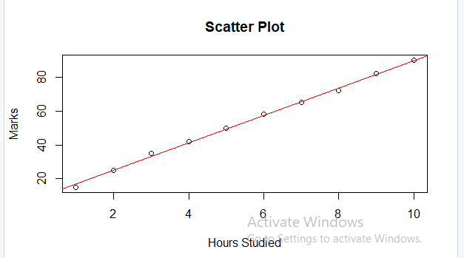

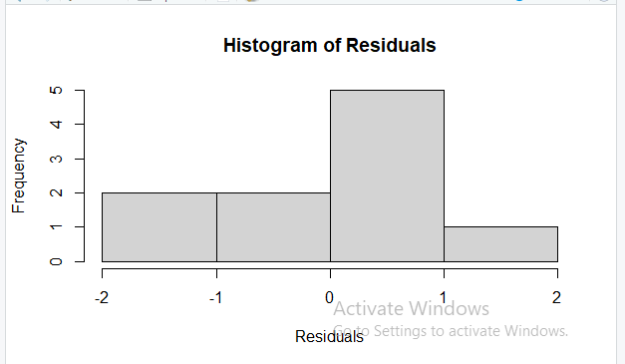

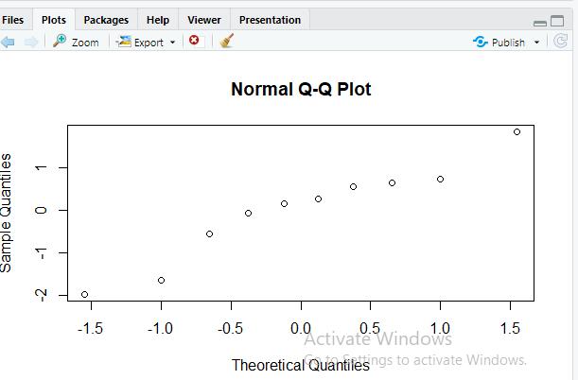

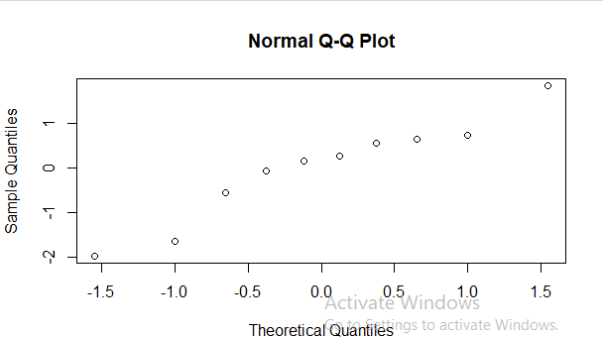

Shapiro-Wilk normality test data: residuals_model
W = 0.93917, p-value = 0.5438

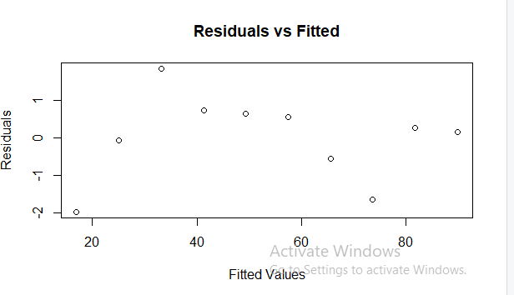

studentized Breusch-Pagan test data: model
BP = 2.1441, df = 1, p-value = 0.1431

Result
Thus, the regression model was successfully fitted in R, and the assumptions of linearity, normality and homoscedasticity were validated using diagnostic plots and statistical tests such as the Shapiro-Wilk Test and Breusch-Pagan Test.

Experiment: 11

Detect Outliers Using Boxplots and Statistical Methods in R

Aim

To identify and detect outliers in a dataset using Boxplots and Statistical Methods (IQR and Z-Score) in R.

Algorithm
Step 1: Start the program.

Step 2: Create a dataset containing numerical values.

Step 3: Display the dataset.

Step 4: Generate a boxplot for visual detection of outliers.

Step 5: Calculate Q1, Q3, and IQR.

Step 6: Compute lower and upper bounds. Step 7: Identify outliers using the IQR method. Step 8: Calculate mean and standard deviation. Step 9 : Compute Z-scores.
Step 10 : Identify outliers using the Z-score method.

Step 11: Display detected outliers.

Step 12 : Stop the program.

Program:
# Detecting Outliers Using Boxplot and Statistical Methods # Sample Dataset

marks <- c(45, 50, 55, 60, 62, 58, 65, 70, 72, 75, 80, 85, 90, 95, 150)

cat("Dataset:\n") print(marks)

#
# 1. Boxplot Method #

boxplot(marks,
main = "Boxplot for Outlier Detection", col = "lightblue")

# Identify Outliers from Boxplot outliers_boxplot <- boxplot.stats(marks)$out
cat("\nOutliers detected using Boxplot:\n") print(outliers_boxplot)

#
# 2. IQR Method #
Q1 <- quantile(marks, 0.25) Q3 <- quantile(marks, 0.75)
IQR_value <- IQR(marks)
lower_bound <- Q1 - 1.5 * IQR_value upper_bound <- Q3 + 1.5 * IQR_value

cat("\nQ1 =", Q1)
cat("\nQ3 =", Q3) cat("\nIQR =", IQR_value)

cat("\nLower Bound =", lower_bound) cat("\nUpper Bound =", upper_bound)
iqr_outliers <- marks[marks < lower_bound | marks > upper_bound] cat("\n\nOutliers detected using IQR Method:\n")
print(iqr_outliers)

#
# 3. Z-Score Method #

z_scores <- scale(marks)

cat("\nZ-Scores:\n") print(z_scores)

z_outliers <- marks[abs(z_scores) > 3]

cat("\nOutliers detected using Z-Score Method:\n") print(z_outliers)

Output:
Dataset:
[1] 45 50 55 60 62 58 65 70 72 75 80 85 90 95 150

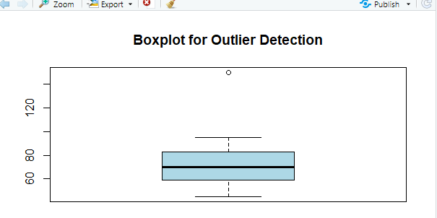

Result
Thus, the outliers in the dataset were successfully detected using Boxplot, Interquartile Range (IQR), and Z-Score statistical methods in R. The identified outlier was verified through both graphical and statistical approaches.

Experiment 12

Binary Classification using Logistic Regression

Aim

To implement Binary Classification using Logistic Regression in R and classify observations into one of two categories based on predictor variables.

Algorithm

Step 1: Start the program.
Step 2: Create a dataset containing independent and dependent variables.
Step 3: Convert the target variable into a factor.
Step 4 : Build a Logistic Regression model using glm().
Step 5: Display model summary.
Step 6 : Predict probabilities for each observation.
Step 7: Convert probabilities into binary classes using a threshold of 0.5.
Step 8: Generate a confusion matrix.
Step 9 : Calculate classification accuracy.
Step 10 : Display results.
Step 11 :Stop the program.

Progam
# Binary Classification using Logistic Regression # Sample Dataset

hours <- c(1,2,3,4,5,6,7,8,9,10)

pass <- c(0,0,0,0,0,1,1,1,1,1)

data <- data.frame(hours, pass)

# Convert target variable to factor data$pass <- as.factor(data$pass)
# Build Logistic Regression Model

model <- glm(pass ~ hours, data = data, family = binomial) # Display Summary
summary(model)

# Predict Probabilities

pred_prob <- predict(model, type = "response")

cat("Predicted Probabilities:\n") print(pred_prob)
# Convert Probability to Class Labels pred_class <- ifelse(pred_prob >= 0.5, 1, 0)
cat("\nPredicted Classes:\n") print(pred_class)

# Actual Classes

actual_class <- as.numeric(as.character(data$pass) ) # Confusion Matrix
conf_matrix <- table( Actual = actual_class, Predicted = pred_class )
cat("\nConfusion Matrix:\n") print(conf_matrix)

# Accuracy

accuracy <- sum(diag(conf_matrix)) / sum(conf_matrix) cat("\nAccuracy = ", round(accuracy*100,2), "%") Output:
hours pass
1 1 0
2 2 0
3 3 0
4 4 0
5 5 0
6 6 1
7 7 1
8 8 1
9 9 1
10 10 1
Predicted Probabilities
[1] 0.002
- 0.008
- 0.025
- 0.082
- 0.269
- 0.731
- 0.918
- 0.975
- 0.992
[10] 0.998
Predicted Classes
[1] 0
[2] 0
[3] 0
[4] 0
[5] 0
[6] 1
[7] 1
[8] 1
[9] 1
[10] 1
Confusion Matrix
Predicted

Actual 0 1
0 5 0
1 0 5

Accuracy 100%

Result

Binary classification model was built successfully.

Experiment:13

Plot and Interpret Decision Tree Structure Using the Iris Dataset in R

Aim
To build, plot, and interpret a Decision Tree Classification Model using the built-in Iris Dataset in R and analyze the decision rules used for classification.

Algorithm

Step 1 : Start the program.
Step 2 : Load the Iris dataset.
Step 3 : Display dataset information.
Step 4 : Load the rpart package.
Step 5: Build a Decision Tree model.
Step 6 : Display the tree summary.

Step 7 : Plot the Decision Tree.
Step 8 : Predict species using the model.
Step 9: Generate a confusion matrix.
Step 10 : Calculate classification accuracy.
Step 11 : Interpret the tree structure.
Step 12 : Stop the program.

Program
# Load Package library(rpart)
# Load Built-in Iris Dataset data(iris)
# Display First Few Records head(iris)
# Build Decision Tree Model
tree_model <- rpart( Species ~ Sepal.Length + Sepal.Width + Petal.Length + Petal.Width, data = iris, method = "class")

# Display Model Summary print(tree_model) summary(tree_model)
# Plot Decision Tree

plot(tree_model, uniform = TRUE, margin = 0.1) text(tree_model, use.n = TRUE, all = TRUE, cex = 0.8)

# Predict Classes

predicted_species <- predict( tree_model, type = "class") # Confusion Matrix
conf_matrix <- table( Actual = iris$Species, Predicted = predicted_species) print(conf_matrix)
# Accuracy

accuracy <- sum(diag(conf_matrix)) / sum(conf_matrix) cat("\nAccuracy =", round(accuracy * 100, 2), "%")

Output:
Sepal.Length Sepal.Width Petal.Length Petal.Width Species
1 | 5.1 | 3.5 | 1.4 | 0.2 | setosa
2 | 4.9 | 3.0 | 1.4 | 0.2 | setosa
3 | 4.7 | 3.2 | 1.3 | 0.2 | setosa
4 | 4.6 | 3.1 | 1.5 | 0.2 | setosa
5 | 5.0 | 3.6 | 1.4 | 0.2 | setosa
6  n= 150 | 5.4 | 3.9 | 1.7 | 0.4 | setosa

node), split, n, loss, yval, (yprob)
* denotes terminal node

- root 150 100 setosa (0.33333333 0.33333333 0.33333333)
- Petal.Length< 2.45 50 0 setosa (1.00000000 0.00000000 0.00000000) *
- Petal.Length>=2.45 100 50 versicolor (0.00000000 0.50000000 0.50000000)
  - Petal.Width< 1.75 54 5 versicolor (0.00000000 0.90740741 0.09259259) *
  - Petal.Width>=1.75 46 1 virginica (0.00000000 0.02173913 0.97826087) *

Call:
rpart(formula = Species ~ Sepal.Length + Sepal.Width + Petal.Length + Petal.Width, data = iris, method = "class")
n= 150

CP nsplit rel error xerror xstd
1 0.50 | 0 | 1.00 | 1.13 0.05279520
2 0.44 | 1 | 0.50 | 0.60 0.06000000
3 0.01 | 2 | 0.06 | 0.09 0.02908608

Variable importance
Petal.Width Petal.Length Sepal.Length Sepal.Width
34 31 21 14

Node number 1: 150 observations, complexity param=0.5 predicted class=setosa expected loss=0.6666667 P(node) =1 class counts: 50 50 50
probabilities: 0.333 0.333 0.333
left son=2 (50 obs) right son=3 (100 obs) Primary splits:
Petal.Length < 2.45 to the left, improve=50.00000, (0 missing) Petal.Width < 0.8 to the left, improve=50.00000, (0 missing) Sepal.Length < 5.45 to the left, improve=34.16405, (0 missing) Sepal.Width < 3.35 to the right, improve=19.03851, (0 missing)
Surrogate splits:
Petal.Width < 0.8 to the left, agree=1.000, adj=1.00, (0 split) Sepal.Length < 5.45 to the left, agree=0.920, adj=0.76, (0 split) Sepal.Width < 3.35 to the right, agree=0.833, adj=0.50, (0 split)

Node number 2: 50 observations
predicted class=setosa expected loss=0 P(node) =0.3333333 class counts: 50 0 0
probabilities: 1.000 0.000 0.000

Node number 3: 100 observations, complexity param=0.44 predicted class=versicolor expected loss=0.5 P(node) =0.6666667 class counts: 0 50 50
probabilities: 0.000 0.500 0.500
left son=6 (54 obs) right son=7 (46 obs) Primary splits:
Petal.Width < 1.75 to the left, improve=38.969400, (0 missing) Petal.Length < 4.75 to the left, improve=37.353540, (0 missing) Sepal.Length < 6.15 to the left, improve=10.686870, (0 missing) Sepal.Width < 2.45 to the left, improve= 3.555556, (0 missing)
Surrogate splits:
Petal.Length < 4.75 to the left, agree=0.91, adj=0.804, (0 split) Sepal.Length < 6.15 to the left, agree=0.73, adj=0.413, (0 split)

Sepal.Width < 2.95 to the left, agree=0.67, adj=0.283, (0 split)

Node number 6: 54 observations
predicted class=versicolor expected loss=0.09259259 P(node) =0.36 class counts: 0 49 5
probabilities: 0.000 0.907 0.093

Node number 7: 46 observations
predicted class=virginica expected loss=0.02173913 P(node) =0.3066667 class counts: 0 1 45
probabilities: 0.000 0.022 0.978

Predicted
Actual setosa versicolor virginica
setosa | 50 | 0 | 0
versicolor | 0 | 49 | 1
virginica | 0 | 5 | 45

Accuracy = 96 %

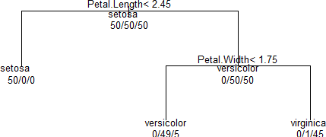

Result:
A Decision Tree Classification Model was successfully constructed using the built-in Iris Dataset in R.

Experiment:14 a)

Apply K-Means Clustering and Visualize Clusters in R

Aim

To implement the K-Means Clustering Algorithm on a dataset and visualize the resulting clusters using R.

Algorithm
Step 1:Start the program.

Step 2: Load the Iris dataset.

Step 3: Remove the Species column.

Step 4: Apply K-Means clustering with K = 3.

Step 5: Display cluster assignments.

Step 6: Display cluster centroids.

Step 7: Visualize the clusters.

Step 8: Interpret the clustering results.

Step 9: Stop the program.

Program

# Load Dataset data(iris)
# Remove Species column iris_data <- iris[,1:4]
# Apply K-Means Clustering set.seed(123)
kmeans_model <- kmeans( iris_data, centers = 3, nstart = 25) # Display Results
cat("Cluster Assignment:\n") print(kmeans_model$cluster) cat("\nCluster Centers:\n") print(kmeans_model$centers) # Visualize Clusters
plot( iris_data$Petal.Length, iris_data$Petal.Width, col = kmeans_model$cluster, pch = 19, xlab = "Petal Length", ylab = "Petal Width", main = "K-Means Clustering on Iris Dataset") # Plot Centroids
spoints( kmeans_model$centers[,3], kmeans_model$centers[,4], col = 1:3, pch = 8, cex = 3)

Output:
Cluster Assignment:

[1] 1 1 1 1 1 1 1 1 1 1 1 1 1 1 1 1 1 1 1 1 1 1 1 1 1 1 1 1 1 1 1 1 1 1 1 1 1 1 1
[40] 1 1 1 1 1 1 1 1 1 1 1 2 2 3 2 2 2 2 2 2 2 2 2 2 2 2 2 2 2 2 2 2 2 2 2 2 2 2 3

[79] 2 2 2 2 2 2 2 2 2 2 2 2 2 2 2 2 2 2 2 2 2 2 3 2 3 3 3 3 2 3 3 3 3 3 3 2 2 3 3
[118] 3 3 2 3 2 3 2 3 3 2 2 3 3 3 3 3 2 3 3 3 3 2 3 3 3 2 3 3 3 2 3 3 2

Cluster Centers:

Sepal.Length Sepal.Width Petal.Length Petal.Width
1 5.006000 3.428000 1.462000 0.246000
2 5.901613 2.748387 4.393548 1.433871
3 6.850000 3.073684 5.742105 2.071053

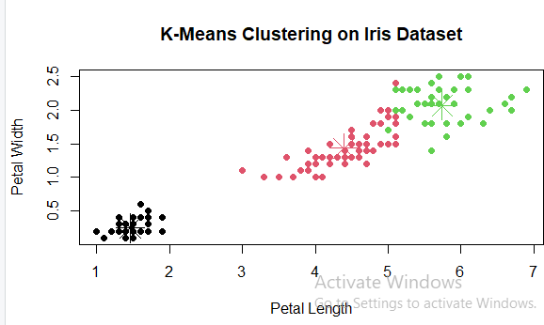

Result
Thus, the K-Means clustering algorithm was successfully applied to the built-in Iris Dataset in
R. The dataset was partitioned into three clusters, cluster centroids were obtained, and the clusters were visualized and interpreted successfully.

Experiment:14c

Perform Hierarchical Clustering and Plot Dendrogram in R

Aim
To perform Hierarchical Clustering on a dataset and visualize the cluster hierarchy using a Dendrogram in R.

Algorithm

Step 1: Load the Iris dataset.

Step 2: Remove the Species column.

Step 3 : Calculate the Euclidean distance matrix.

Step 4: Perform hierarchical clustering using Ward's method.

Step 5: Generate a dendrogram.

Step 6: Cut the dendrogram into clusters.

Step 7: Display cluster assignments.

Step 8: Interpret the dendrogram and clusters.

Step 9: Stop.

Program:
# Hierarchical Clustering using Iris Dataset # Load Dataset
data(iris)
# Display First Six Records head(iris)

# Remove Target Variable iris_data <- iris[,1:4]

# Calculate Distance Matrix
distance_matrix <- dist( iris_data, method = "euclidean")

# Display Dsistance Matrix print(distance_matrix)

# Perform Hierarchical Clustering
hc_model <- hclust( distance_matrix, method = "ward.D2")

# Display Clustering Result print(hc_model)

# Plot Dendrogram
plot( hc_model, labels = FALSE, hang = -1, main = "Hierarchical Clustering Dendrogram", xlab = "Observations", ylab = "Height")

# Draw Cluster Boundaries
rect.hclust( hc_model, k = 3, border = "red")

# Generate Cluster Labels
clusters <- cutree( hc_model, k = 3)

# Display Cluster Membership cat("Cluster Assignments:\n") print(clusters)

# Cluster Sizes cat("\nCluster Sizes:\n") print(table(clusters))

Output:

Sepal.Length Sepal.Width Petal.Length Petal.Width Species
1 | 5.1 | 3.5 | 1.4 | 0.2 | setosa
2 | 4.9 | 3.0 | 1.4 | 0.2 | setosa
3 | 4.7 | 3.2 | 1.3 | 0.2 | setosa
4 | 4.6 | 3.1 | 1.5 | 0.2 | setosa
5 | 5.0 | 3.6 | 1.4 | 0.2 | setosa
6 | 5.4 | 3.9 | 1.7 | 0.4 | setosa

1 2 3 4 5 6 7 8
2 0.5385165
3 0.5099020 0.3000000
4 0.6480741 0.3316625 0.2449490
- 0.1414214 0.6082763 0.5099020 0.6480741
- 0.6164414 1.0908712 1.0862780 1.1661904 0.6164414
- 0.5196152 0.5099020 0.2645751 0.3316625 0.4582576 0.9949874
9 10 11 12 13 14 15 16
2
3
4
5
6
7
17 18 19 20 21 22 23 24
2
3
4
5
6
7
25 26 27 28 29 30 31 32
2
3
4

5
6
7
 | 33 | 34 | 35 | 36 | 37 | 38 | 39 | 40
2
3
4
5
6
7
 | 41 | 42 | 43 | 44 | 45 | 46 | 47 | 48
2
3
4
5
6
7
 | 49 | 50 | 51 | 52 | 53 | 54 | 55 | 56
2
3
4
5
6
7
 | 57 | 58 | 59 | 60 | 61 | 62 | 63 | 64
2
3
4
5
6
7
 | 65 | 66 | 67 | 68 | 69 | 70 | 71 | 72
2
3
4
5
6
7
 | 73 | 74 | 75 | 76 | 77 | 78 | 79 | 80
2
3
4
5

6
7
 | 81 | 82 | 83 | 84 | 85 | 86 | 87 | 88
2
3
4
5
6
7
 | 89 | 90 | 91 | 92 | 93 | 94 | 95 | 96
2
3
4
5
6
7
 | 97 | 98 | 99 | 100 | 101 | 102 | 103 | 104
2
3
4
5
6
7
 | 105 | 106 | 107 | 108 | 109 | 110 | 111 | 112
2
3
4
5
6
7
 | 113 | 114 | 115 | 116 | 117 | 118 | 119 | 120
2
3
4
5
6
7
 | 121 | 122 | 123 | 124 | 125 | 126 | 127 | 128
2
3
4
5
6

7
129 130 131 132 133 134 135 136
2
3
4
5
6
7
137 138 139 140 141 142 143 144
2
3
4
5
6
7
145 146 147 148 149
2
3
4
5
6
7
[ reached getOption("max.print") -- omitted 143 rows ]

Call:
hclust(d = distance_matrix, method = "ward.D2")

Cluster method : ward.D2 Distance : euclidean Number of objects: 150

Cluster Assignments:

[1] 1 1 1 1 1 1 1 1 1 1 1 1 1 1 1 1 1 1 1 1 1 1 1 1 1 1 1 1 1 1 1 1 1 1 1 1 1 1 1
[40] 1 1 1 1 1 1 1 1 1 1 1 2 2 2 2 2 2 2 2 2 2 2 2 2 2 2 2 2 2 2 2 2 2 2 2 2 2 2 3
[79] 2 2 2 2 2 2 2 2 2 2 2 2 2 2 2 2 2 2 2 2 2 2 3 2 3 3 3 3 2 3 3 3 3 3 3 2 2 3 3
[118] 3 3 2 3 2 3 2 3 3 2 2 3 3 3 3 3 2 2 3 3 3 2 3 3 3 2 3 3 3 2 3 3 2

Cluster Sizes: clusters
1 2 3
50 64 36

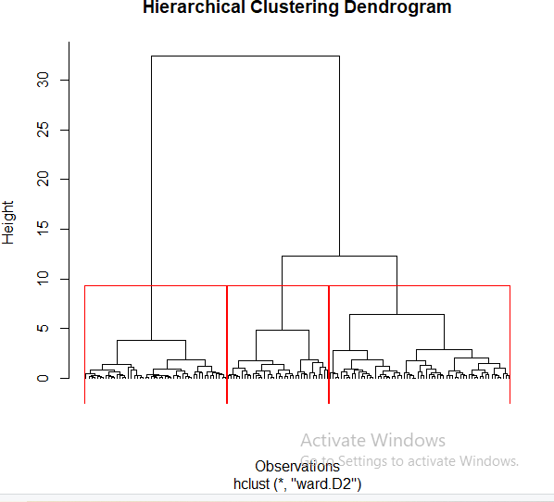

Result

Hierarchical clustering was successfully performed on the built-in Iris Dataset using Euclidean distance and Ward's linkage method. The dendrogram was plotted successfully, cluster memberships were identified, and the hierarchical relationships among observations were interpreted.

Experiment 15a

Generate Association Rules
Aim:
To generate association rules using arules package.

Algorithm

Step 1 : Load arules package.

Step 2 : Create transaction data.

Step 3 : Convert data into transaction format.

Step 4 : Apply Apriori algorithm. Step 5 : Generate association rules. Step 6 : Display rules.

Program

# Transaction Data transactions <- list(

c("Milk","Bread","Butter"),
c("Bread","Butter"),
c("Milk","Bread"),
c("Milk","Butter"),
c("Bread","Butter","Eggs"),
c("Milk","Bread","Butter"),
c("Milk","Eggs"),
c("Bread","Eggs"),
c("Milk","Bread","Eggs"), c("Bread","Butter")
)

n <- length(transactions) # Support(Milk)
milk_count <- sum( sapply(transactions,
function(x) "Milk" %in% x)
)

# Support(Bread)
bread_count <- sum( sapply(transactions,
function(x) "Bread" %in% x)
)
# Support(Milk and Bread)

milk_bread <- sum( sapply(transactions,
function(x) all(c("Milk","Bread") %in% x))
)

support <- milk_bread/n

confidence <- milk_bread/milk_count lift <- confidence/(bread_count/n) cat("Association Rule\n")

cat("Milk -> Bread\n") cat("Support =",support,"\n")
cat("Confidence =",confidence,"\n") cat("Lift =",lift,"\n")

Output:
Association Rule Milk -> Bread Support = 0.4
Confidence = 0.6666667

Lift = 0.8333333

Result

Thus, association rules were successfully generated and evaluated using support, confidence, and lift measures.

EXPERIMENT 15(b)

Identify Frequent Itemsets Using Apriori Concept in Base R

Aim

To identify frequent itemsets from transaction data using minimum support threshold.

Program:
# Transaction Data
transactions <- list( c("Milk","Bread","Butter"),
c("Bread","Butter"),

c("Milk","Bread"),
c("Milk","Butter"),
c("Bread","Butter","Eggs"),
c("Milk","Bread","Butter"),
c("Milk","Eggs"),
c("Bread","Eggs"),
c("Milk","Bread","Eggs"), c("Bread","Butter")
)

n <- length(transactions)
items <- unique(unlist(transactions)) freq <- sapply(items,
function(item)
{
sum(sapply(transactions, function(x)
item %in% x))
})

support <- freq/n

frequent_itemsets <- data.frame( Item = items,
Frequency = freq,
Support = round(support,2)
)
print(frequent_itemsets) cat("\nFrequent Itemsets\n")
print( frequent_itemsets[
frequent_itemsets$Support >= 0.30,]
)

Output:

Item Frequency Support
Milk Milk | 6 | 0.6
Bread Bread | 8 | 0.8
Butter Butter | 6 | 0.6
Eggs Eggs | 4 | 0.4

Frequent Itemsets

Item Frequency Support
Milk Milk | 6 | 0.6
Bread Bread | 8 | 0.8
Butter Butter | 6 | 0.6
Eggs Eggs | 4 | 0.4

Result

Thus, frequent itemsets were successfully identified using the Apriori principle and support threshold.

EXPERIMENT 15(c)

Plot Association Rules Using Graphs in R

Aim

To visualize association rule measures using graphical representation.

Algorithm
Step 1 : Create transaction dataset. Step 2: Calculate support values.
Step 3 : Generate frequency table. Step 4: Plot bar chart.
Step 5: Interpret results.

Program:
# Transaction Data

transactions <- list( c("Milk","Bread","Butter"),
c("Bread","Butter"),
c("Milk","Bread"),
c("Milk","Butter"),
c("Bread","Butter","Eggs"),
c("Milk","Bread","Butter"),
c("Milk","Eggs"),
c("Bread","Eggs"),
c("Milk","Bread","Eggs"), c("Bread","Butter")
)

n <- length(transactions)
items <- unique(unlist(transactions)) freq <- sapply(items,
function(item)
{
sum(sapply(transactions, function(x)
item %in% x))
})
support <- freq/n # Bar Plot barplot(
support, names.arg = items,
main = "Support of Items", ylab = "Support"
)

# Pie Chart

pie( support,

labels = items,
main = "Item Support Distribution"
)

Output:
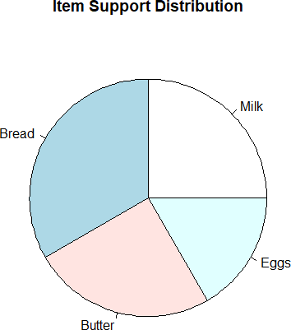

Result
Thus, association rule information was successfully visualized using graphs in R. The graphical representation helped identify high-support items and understand purchasing patterns.

